MAZDASPEED/MPS/CX-7 VersaTuner Order Form
&
Stratified Custom Tuning Instructions

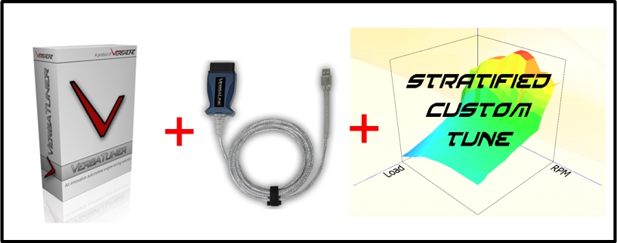

Stratified Legal Disclaimer

LEGAL STATEMENT – PLEASE READ CAREFULLY

Below is the limited liability statement that governs the relationship between you, the customer, and Stratified Automotive Controls LTD. during the custom calibration process. Please read carefully. Once read and understood, please e-mail the following statement to your Stratified Automotive Controls LTD.

"I understand the risks of tuning and understand that Stratified is not liable for damages, costs, injuries that may be incurred in my working relationship with them."

ALL parts and services are sold for OFF ROAD, RACE-ONLY ground vehicle use only.
Aftermarket calibrations and systems interacting with engine function are not for use on pollution controlled vehicles. Alteration of emission related components constitutes tampering under most local emission regulation guidelines and can lead to fines and penalties.

Stratified Automotive Controls LTD. is not responsible for any fines, injuries, costs, or damages incurred as a result of the tuning process or our relationship with you, the customer. It is the complete responsibility of the customer to ensure their vehicle is operating in a safe and lawful manner, respecting all local laws and regulations.

Stratified Automotive Controls LTD does not offer or imply any warranty or guarantee for the results or outcome of the calibrations sent to the customer during the tuning process.

VersaTuner Bundle Order and Information Form

Thank you for purchasing the Stratified Custom Tune and VersaTuner Bundle!
To start the process, we must first set you up with VersaTuner and find out more about your vehicle and intentions for the tune. To do so, please fill out all the fields in the following form. If you have any questions, please don't hesitate to Contact Us.
First Name:

Last Name:

E-mail Address:

Shipping Address (for VersaLink cable):

Vehicle Year:

Vehicle Model:

Vehicle VIN:

Vehicle Modifications Installed:

Fuel you are currently using:

Tuning Goals (What are you trying to achieve with the tune and under what conditions is the vehicle driven - track/daily/etc.) :

I have read and agree to the terms of the VersaTuner license agreement

I have read and agree to the terms of the Stratified LEGAL STATEMENT

VersaTuner software specifically built for your vehicle and VIN will be made available to download for you. The download link will be automatically sent to your e-mail.

The VersaLink cable will be shipped to the address you specified above.

Stratified Custom Tuning Procedure for the Mazdaspeed/MPS 3/6 and CX-7 Using VersaTuner

Once you have received VersaTuner and the VersaLink Cable and have installed it, the tuning process itself is pretty straight forward and you will get a chance to interact with an experienced individual that has worked with these vehicles extensively. The tuning time starts when we have sent you your first map, so don't worry if it's taking a few days to get the software setup.
Your tuner will ask for certain datalogs and in turn will be sending you map revisions, and provide coaching along the way to help you achieve your tuning goals. This process will continue until you and your tuner are happy or the tuning time purchased expires. Since there is an expiration period for the tune it is important to have your hardware in order and be prepared to datalog quickly after receiving a new iteration of the tune. Depending on goals and vehicle setup, it usually takes a few iterations to get everything dialled in. During this time, contact your tuner with any questions you may have.
Once VersaTuner is setup, you will have to send your tuner the following data files via e-mail:
1. A MAF calibration datalog
2. A wide open throttle (WOT) datalog
These items are all described below.

A MAF Calibration Datalog
The mass air flow sensor (MAF) is one of the most important sensors in the car as it tells the ECU how much air the motor is ingesting so that it knows how much fuel to deliver. When using aftermarket intakes, the MAF tables must be adjusted and a MAF calibration log must be done.
1. To do this, the following parameters need to be logged:
Engine RPM
Short Term Fuel Trim (Primary Sensor)
Short Term Fuel Trim (Secondary Sensor)
Long Term Fuel Trim
Mass Airflow (g/s)
Mass Airflow Sensor Voltage
2. If you have a map flashed right now, make sure it has been on the car for at least one hundred miles.
3. Warm up the car - 15-20 minutes normal driving. Turn off the A/C when starting to log.
4. Display the MAF (g/s) so you can watch this as you're logging.
5. Start in 2nd gear at 1500RPM and slowly accelerate steadily looking at the MAF (g/s) smoothly rising to 100g/s. Go to the next gear and continue applying more boost and throttle trying to smoothly increase MAF (g/s) until you're close to 200 g/s. You should be well into boost by this point. Save this log as MAF cal.
6. Convert these logs (and all others) to .csv and send these to your tuner.

A WOT Datalog
If the car is running well and safely, your tuner will need to see how the car responds under WOT conditions.
1. To do this, the following parameters need to be logged:
Engine RPM
Actual Air To Fuel Ratio
Absolute Load
Boost Air Temperature
Fuel Rail Pressure
Ignition Timing Advance
Intake Manifold Absolute Pressure
Knock Retard
Mass Airflow
Relative Throttle Position
Wastegate Control Solenoid Duty Cycle
Vehicle Speed
2. Make sure the car is warmed up and find a nice long flat safe piece of road to do two 3rd or 4th gear WOT datalogs (4th is generally better since the loads are higher but only do this if the conditions allow). Remember to most importantly be safe!
3. Perform these full gear pulls from 3000 RPM to 6500 RPM.
4. Make sure the car has the fuel you usually run in it and plan on running. Keep using this same fuel during the entire tuning process and thereafter or let your tuner know otherwise. Fuel quality has a high impact on the performance of the DISI engine.
5. If you run methanol injection for cooling alone, turn it off for these runs.
6. Try to do these and future logs on the same stretch of road that is flat. This way the performance of the car can easily be analyzed as you and your tuner adjust the tune.
7. Convert these logs (and all others) to .csv and send these to your tuner.

Relevant Vehicle and Tuning Information

Vehicle Information and Modifications
Your tuner must know what modifications you have installed or of any other special issues with your vehicle. As power increases, OEM (and some aftermarket) hardware will become incapable of keeping up. It's not uncommon to see the CDFP (cam driven high pressure fuel pump) not keep up with increased power and boost. There are aftermarket solutions for most parts that require upgrading.
Make sure all your hardware is in tip- top shape. Tuning around a hardware issue (like an exhaust leak, or a boost / vacuum leak) will only complicate things and result in a much more difficult and costly tuning process.
Also (as I am sure you know this) be aware that the increased loads and stresses due to more power on your motor can negatively impact reliability. We use our extensive experience and common sense to deliver a safe and powerful tune to your liking; but you are the one in the driver's seat and you have the control over the situation and your vehicle.
Finally, all performance parts should be installed on the vehicle before the tuning starts. Installing parts mid-tune will extend the tuning period and may require the purchase of additional tuning time.

E85 blends
If using E85 blends, it has been shown that a 1/3 (25%) mix is effective and mild on your fuel system and pump. When mixing E85, make sure you always mix in the same proportions during every fill-up. For example, if you are adding 3 gallons of E85, add 9 gallons of gasoline. If you are adding 1 gallon of E85, add 3 gallons of gasoline etc.

Your Tuning Goals
Let your tuner know what your overall tuning goals are. Let them know if there are particular conditions under which the car will be operating (extreme heat or cold, or being tracked often). This will help the tuner build a tune that caters to your driving environment and needs.
Thank you,
The Stratified Team

