Stratified Ford Ecoboost
S-OTS+ MAP Form

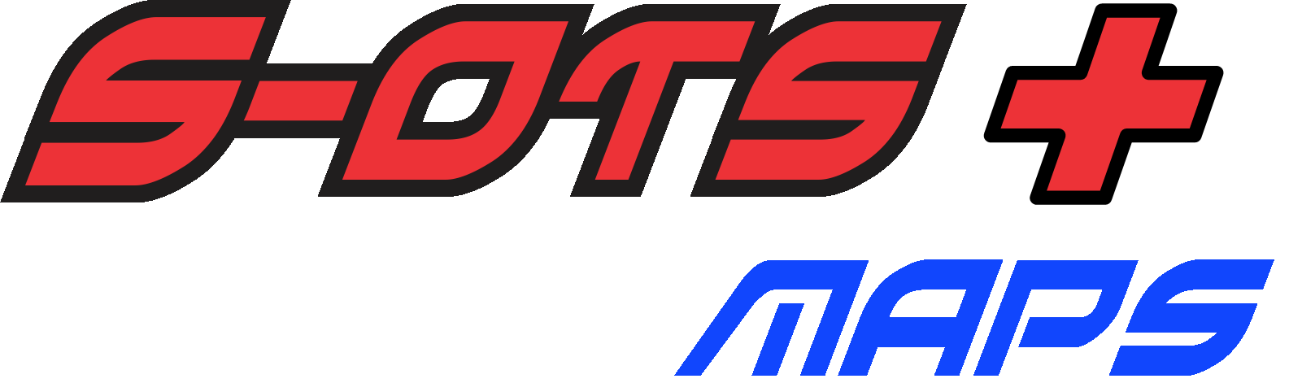

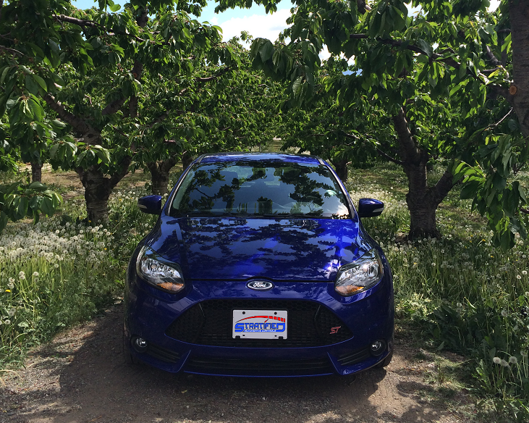

LEGAL STATEMENT – PLEASE READ CAREFULLY

Below is the limited liability statement that governs the relationship between you, the customer, and Stratified Automotive Controls LTD. during the custom calibration process. Please read carefully. Once read and understood, please e-mail the following statement to your Stratified Automotive Controls LTD.

"I understand the risks of tuning and understand that Stratified is not liable for damages, costs, injuries that may be incurred in my working relationship with them."

ALL parts and services are sold for OFF ROAD, RACE-ONLY ground vehicle use only.
Aftermarket calibrations and systems interacting with engine function are not for use on pollution controlled vehicles. Alteration of emission related components constitutes tampering under most local emission regulation guidelines and can lead to fines and penalties.

Stratified Automotive Controls LTD. is not responsible for any fines, injuries, costs, or damages incurred as a result of the tuning process or our relationship with you, the customer. It is the complete responsibility of the customer to ensure their vehicle is operating in a safe and lawful manner, respecting all local laws and regulations.

Stratified Automotive Controls LTD does not offer or imply any warranty or guarantee for the results or outcome of the calibrations sent to the customer during the tuning process.

Stratified S-OTS+ Tuning Information for the Ford Ecoboost Using the COBB AP
Thank you for purchasing the Stratified S-OTS+ Tune for your vehicle! The form below must be completed for you to receive the S-OTS+ map you have ordered. Please make sure all information below is correct. Also please remember the following:

- The Stratified S-OTS+ calibration is a specially designed Stratified calibration adapted for your particular modifications.
- The S-OTS+ tune contains the latest tuning strategies employed by Stratified to make your Ford both perform and be enjoyable to drive in all conditions.
- The S-OTS+ calibration is NOT a fully customized tune for your vehicle. Stratified is not going to analyze logs, troubleshoot symptoms, or be responsible for any mechanical issues that may make this calibration incompatible with your vehicle. The calibration is meant to be safe to use in most vehicles with the K03 OEM turbocharger if the modifications below are specified correctly and pump gas fuel is used.

Your Full Name:
Your Contact E-mail:
Region (USDM, EDM, ADM):
Vehicle Year:
Vehicle Make and Model:
Complete Vehicle Modifications Installed:
Check Engine Light (CEL) Codes to be disabled:
Fuel you are currently using:
Sound Symposer Disabled?
Launch Control RPM in Map Slots 1-4 (if desired): | Map 1:  Map 2:  Map 3:  Map 4:
Enable Flat Foot Shifting @ 5,000 RPM
Low boost (15psi) tune in Map Slot 5
AccessPort Serial Number:
How did you hear about Stratified?
Why did you choose Stratified for tuning?
 | I have read and agree to the terms of the Stratified LEGAL STATEMENT and I understand the risks of tuning and understand that Stratified is not liable for damages, costs, injuries that may be incurred in my working relationship with them.
- If you are looking for a full custom tune specifically designed around your particular vehicle, fuel, and modification, the Stratified Custom Tuning process is the next step. The custom tuning process is a one on one experience with a professional tuner designed to fully optimize the calibration/tune to your vehicle.
- If the information below is incomplete or incorrect and you get a map that does not work for your vehicle you must either get a full custom tune or purchase another S-OTS+ map. There are NO revisions performed on S-OTS+ maps.

Your Vehicle Information:
Make sure all your hardware is in tip- top shape. Any tune installed will not function at its best when there is a mechanical issue (like an exhaust leak, or a boost / vacuum leak).
Please fill in the following data above:
Year:
Model of Vehicle (Focus ST, Fiesta ST, etc.):
Check Engine Light Removal:
Specify any CELs that need to be disabled for your vehicle/modifications
Engine and Relevant Modifications (Intake, Exhaust, BPV, etc.):
The fuel you are using:
Specify the octane rating of the fuel you are using. However be aware that fuel quality does differ from area to area. Always use the best fuel available in your area.
Launch Control RPM in Map Slots 1-4 (if desired):
We can setup different launch control RPMs for your tune in Switchable Map Slots 1-4. Most street tire cars have this set up between 2500 and 3500 RPM.
Map Switching information can be found here:
Map Switching COBB Video
Enable Flat Foot Shifting (if desired):
We can enabled flat foot shifting on all the high performance (Slots 1-4) tunes.
Low boost (15psi) tune in Map Slot 5:
The main (high performance) tune will be installed in Slots 1-4. We can setup a low power (15psi) map in Slot 5 for winter/poor conditions/limp home.
AccessPort Serial Number:
On V2 AccessPorts the serial number of your AP is written on the back of the handheld unit and a sample is shown below:
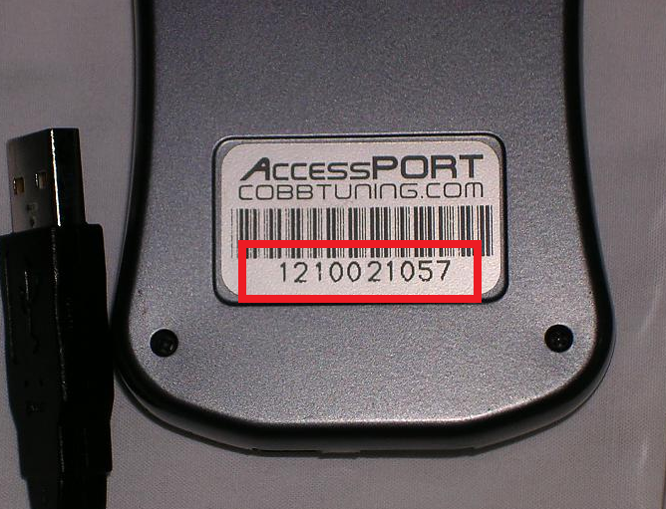
On the V3 AccessPorts the serial is written under the faceplate. The faceplate needs to be removed to see the serial as shown below:
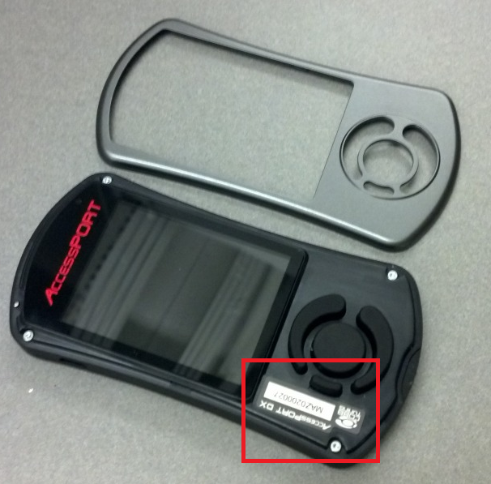
Thank you,
The Stratified Team

