Stratified Technical Support, Tuning, Technical Advice Form

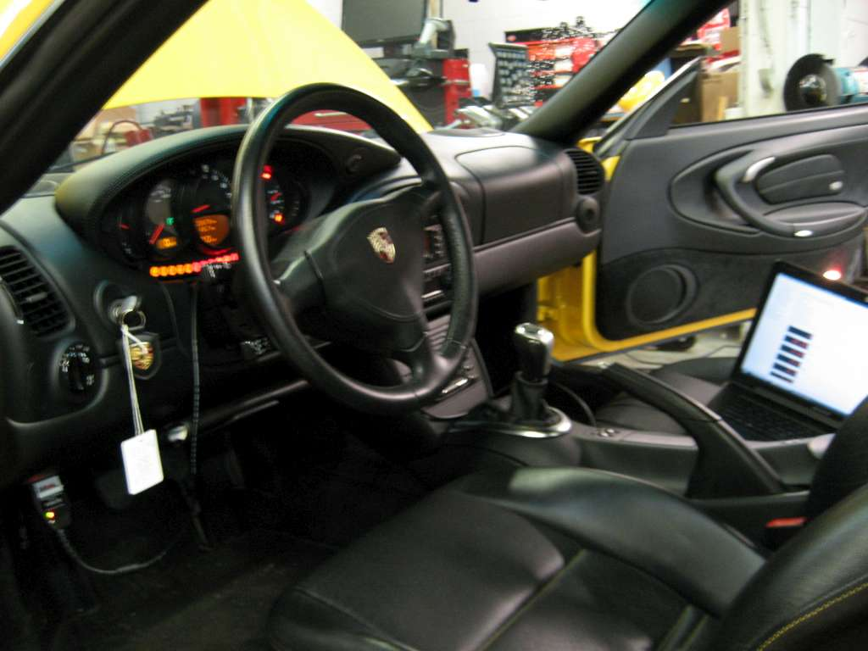

LEGAL STATEMENT – PLEASE READ CAREFULLY

Below is the limited liability statement that governs the relationship between you, the customer, and Stratified Automotive Controls LTD. during the technical support process. Please read carefully. Once read and understood, please e-mail the following statement to your Stratified Automotive Controls LTD.

"I understand the risks of tuning and understand that Stratified is not liable for damages, costs, injuries that may be incurred in my working relationship with them."

Stratified Automotive Controls LTD has extensive automotive expertise and will use this to advise and address the concerns of the customer purchasing these services. However, Stratified Automotive Controls LTD. is not responsible for any fines, injuries, costs, or damages incurred directly or indirectly by you, the customer, as part of you utilizing these services or advice. It is the complete responsibility of the customer to ensure their vehicle is operating in a safe and lawful manner, respecting all local laws and regulations.

Stratified Automotive Controls LTD does not offer or imply any warranty or guarantee for the results or outcome of the technical support or advice supplied to the customer during the technical support process.

Stratified Technical Support Form

Thank you for purchasing Stratified Technical Support! During your interview process with Stratified you will be able to utilize Stratified's extensive knowledge of troubleshooting, vehicle performance, tuning, parts, and pretty much everything vehicle related in a one-on-one session where you can discuss any of the issues that are pertinent to you, your vehicle, and your setup.
In order to make the process a little smoother, provide this completed form when you are contacted about booking your time. This way, we have some time to analyze the topics that you would like to discuss, datalogs, etc. and be prepared for the session.

Your Full Name:
Your E-mail for Relaying Information:
Your Skype Name:
Preferred Interview Time:
Vehicle Year:
Vehicle Make and Model:
Vehicle Modifications Installed:
Description of Advice/Troubleshooting Needed. Be as descriptive and detailed as possible
I have read and agree to the terms of the Stratified LEGAL STATEMENT and I understand the risks of tuning and understand that Stratified is not liable for damages, costs, injuries that may be incurred in my working relationship with them.
Please attach/include datalogs, pictures, or any media that helps illustrate the areas that you'd like to discuss

